书名：大学的理念
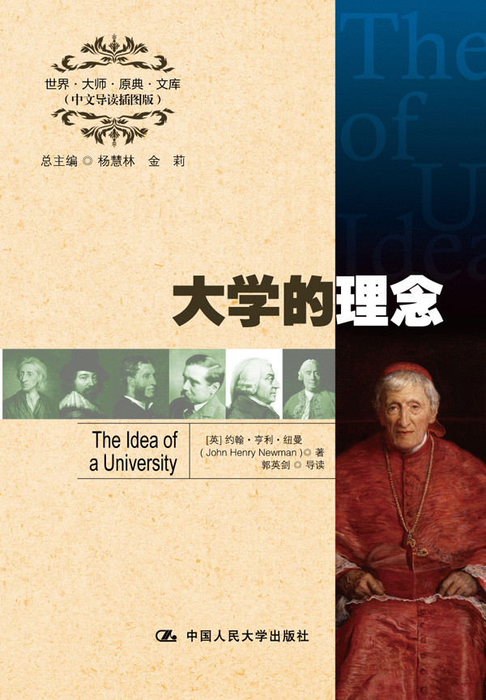

请插入封面
书号：978-7-300-16416-8
著者：[英] 约翰·亨利·纽曼 著
郭英剑 导读
责任编辑：李楠
成品：148*210 页数：460
纸张：70克轻型纸
装祯：平装
出版时间：2012年9月
定价：33.00元
出版社：中国人民大学出版社

- 本书卖点
- 纽曼关于大学的哲学思考
- 全面精彩的中文导读
- 学习英语的珍贵资料

◆ 读者定位
1．全国高等院校英语及相关专业学生
2. 高等院校非英语专业英语学习者及同等英语水平学习者
3. 广大外语教师
4. 哲学、文化、政治及法律等各领域的研究学者及学生

- 作者简介
约翰·亨利·纽曼（1801－1890），19世纪英国著名的教育家、文学家、语言学家和神学家。纽曼出生于一个温和的新教圣公会家庭。1817年6月进入牛津大学三一学院，1820年取得学士学位，并在两年后成为牛津大学奥列尔学院的特别研究员。纽曼在1824年被授予英国国教会的圣职，此间出版10卷布道集。纽曼学识渊博，著述丰富，《大学的理念》是他最重要也是最有影响力的代表作。

- 内容简介
《大学的理念》是西方高等教育史上较早系统、综合、全面地论述大学教育的基本理论问题的名著。在书中，纽曼对自由教育做出了新的界定，对自由教育与专业教育的关系进行了详细的探讨，阐述自由教育的本质和作用，说明大学教育的实质、任务和理想。书中倡导的以古典人文学科教育为主要内容和以注重理性的开发为主要内涵的自由教育理想，在当时及其以后都对世界教育的发展产生了广泛而深远的影响。

◆ 简要目录
Preface
Part One UNIVERSITY TEACHING
Discourse I. Introductory
Discourse II. Theology—A Branch of Knowledge
Discourse III. Bearing of Theology on Other Branches of Knowledge
Discourse IV. Bearing of Other Branches of Knowledge on Theology
Discourse V. Knowledge Its Own End
Discourse VI. Knowledge Viewed in Relation to Learning
Discourse VII. Knowledge Viewed in Relation to Professional Skill
Discourse VIII. Knowledge Viewed in Relation to Religion
Discourse IX. Duties of the Church Towards Knowledge
Part Two UNIVERSITY SUBJECTS, DISCUSSED IN OCCASIONAL LECTURES AND ESSAYS
Lecture I. Christianity and Letters—A Lecture in the School of Philosophy and Letters
Lecture II. Literature—A Lecture in the School of Philosophy and Letters
Lecture III. English Catholic Literature
Lecture IV. Elementary Studies
Lecture V. A Form of Infidelity of the Day
Lecture VI. University Preaching
Lecture VII. Christianity and Physical Science—A Lecture in the School of Medicine Lecture
Lecture VIII. Christianity and Scientific Investigation—A Lecture Written for the School of Science
Lecture IX. Discipline of Mind—An Address to The Evening Classes
Lecture X. Christianity And Medical Science. An Address to the Students Of Medicine·

◆ 上架建议
外语/哲学/畅销书

书摘
The view taken of a University in these Discourses is the following: —That it is a place of teaching universal knowledge. This implies that its object is, on the one hand, intellectual, not moral; and, on the other, that it is the diffusion and extension of knowledge rather than the advancement. If its object were scientific and philosophical discovery, I do not see why a University should have students; if religious training, I do not see how it can be the seat of literature and science.
Such is a University in its essence, and independently of its relation to the Church. But, practically speaking, it cannot fulfill its object duly, such as I have described it, without the Church’s assistance; or, to use the theological term, the Church is necessary for its integrity. Not that its main characters are changed by this incorporation: it still has the office of intellectual education; but the Church steadies it in the performance of that office.
Such are the main principles of the Discourses which follow; though it would be unreasonable for me to expect that I have treated so large and important a field of thought with the fulness and precision necessary to secure me from incidental misconceptions of my meaning on the part of the reader. It is true, there is nothing novel or singular in the argument which I have been pursuing, but this does not protect me from such misconceptions; for the very circumstance that the views I have been delineating are not original with me may lead to false notions as to my relations in opinion towards those from whom I happened in the first instance to learn them, and may cause me to be interpreted by the objects or sentiments of schools to which I should be simply opposed.
For instance, some persons may be tempted to complain, that I have servilely followed the English idea of a University, to the disparagement of that Knowledge which I profess to be so strenuously upholding; and they may anticipate that an academical system, formed upon my model, will result in nothing better or higher than in the production of that antiquated variety of human nature and remnant of feudalism, as they consider it, called “a gentleman.” Now, I have anticipated this charge in various parts of my discussion; if, however, any Catholic is found to prefer it (and to Catholics of course this Volume is primarily addressed), I would have him first of all ask himself the previous question, what he conceives to be the reason contemplated by the Holy See in recommending just now to the Irish Hierarchy the establishment of a Catholic University? Has the Supreme Pontiff recommended it for the sake of the Sciences, which are to be the matter, and not rather of the Students, who are to be the subjects, of its teaching? Has he any obligation or duty at all towards secular knowledge as such? Would it become his Apostolical Ministry, and his descent from the Fisherman, to have a zeal for the Baconian or other philosophy of man for its own sake? Is the Vicar of Christ bound by office or by vow to be the preacher of the theory of gravitation, or a martyr for electro-magnetism? Would he be acquitting himself of the dispensation committed to him if he were smitten with an abstract love of these matters, however true, or beautiful, or ingenious, or useful? Or rather, does he not contemplate such achievements of the intellect, as far as he contemplates them, solely and simply in their relation to the interests of Revealed Truth? Surely, what he does he does for the sake of Religion; if he looks with satisfaction on strong temporal governments, which promise perpetuity, it is for the sake of Religion; and if he encourages and patronizes art and science, it is for the sake of Religion. He rejoices in the widest and most philosophical systems of intellectual education, from an intimate conviction that Truth is his real ally, as it is his profession; and that Knowledge and Reason are sure ministers to Faith.

