书名：道德情操论
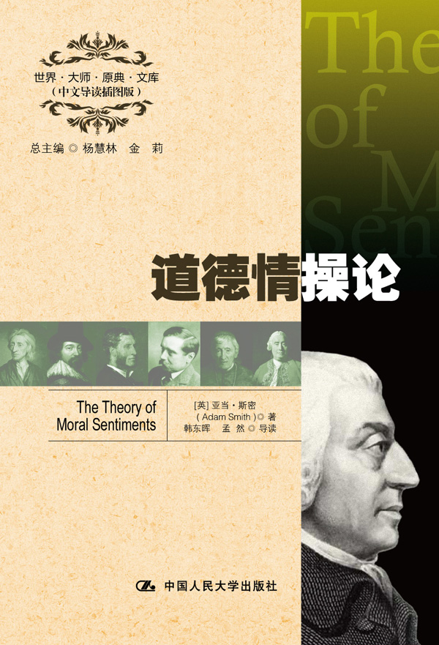

请插入封面
书号：978-7-300-16415-1
著者：[英] 亚当·斯密 著
韩东晖 孟然 导读
责任编辑：王琼
成品：148*210 页数：565
纸张：70克轻型纸
装祯：平装
出版时间：2012年9月
定价：39.00元
出版社：中国人民大学出版社

- 本书卖点
- 斯密对于伦理学的独到见解
- 全面精彩的中文导读
- 学习英语的珍贵资料

◆ 读者定位
1．全国高等院校英语及相关专业学生
2. 高等院校非英语专业英语学习者及同等英语水平学习者
3. 广大外语教师
4. 哲学、文化、政治及法律等各领域的研究学者及学生

- 作者简介
亚当·斯密（1723－1790），英国哲学家和经济学家,是英国古典政治经济学的主要代表人物之一。他在经济学上的主要贡献是创建了政治经济学的科学体系。在价值论上,不仅论证了劳动价值论，而且还确定了这一原理的最早理论体系。他的深刻见解为后来的古典政治经济学奠定了理论基础。他针对资本主义经济的内在发展规律，提出了自由主义经济理论，反对国家干预经济，促进了资本主义经济的发展。

- 内容简介
《道德情操论》是亚当·斯密的伦理学著作，他一生中共修订过六次。斯密从人类的情感和同情心出发，讨论了善恶、美丑、正义、责任等一系列概念，进而揭示出人类社会赖以维系、和谐发展的秘密。

◆ 简要目录
Part Ⅰ Of the Propriety of Action
Section Ⅰ Of the Sense of Propriety
Section Ⅱ Of the Degrees of the Different Passions Which Are Consistent with Propriety Introduction
Section Ⅲ Of the Effects of Prosperity and Adversity upon the Judgment of Mankind with regard to the Propriety of Action; and why it is more easy to obtain their Approbation in the one state than in the other
Part Ⅱ Of Merit and Demerit; or, of the Objects of Reward
Section Ⅰ Of the Sense of Merit and Demerit
Section Ⅱ Of Justice and Beneficence·
Section Ⅲ Of the Influence of Fortune upon the Sentiments of Mankind, with regard to the Merit or Demerit of Actions
Part Ⅲ Of the Foundation of Our Judgments Concerning Our Own Sentiments and Conduct, and of the Sense of Duty
Part Ⅳ Of the Effect of Utility upon the Sentiment of Approbation
Part Ⅴ Of the Influence of Custom and Fashion upon the Sentiments of Moral Approbation and Disapprobation
Part Ⅵ Of the Character of Virtue
Section Ⅰ Of the Character of the Individual, so far as it affects his own Happiness; or of Prudence
Section Ⅱ Of the Character of the Individual, so far as it can affect the Happiness of other People
Section Ⅲ Of Self-command
Conclusion of the Six Part
Part Ⅶ Of Systems of Moral Philosophy
Section Ⅰ Of the Questions which ought to be examined in a Theory of Moral Sentiments
Section Ⅱ Of the different Accounts which have been given of the Nature of Virtue
Section Ⅲ Of the different Systems which have been formed concerning the Principle of Approbation Introduction
Section Ⅳ Of the Manner in which different Authors have treated of the practical Rules of Morality·

◆ 上架建议
外语/哲学/畅销书

书摘
Of the Sense of Propriety
Chap. Ⅰ Of Sympathy
How selfish soever man may be supposed, there are evidently some principles in his nature, which interest him in the fortune of others, and render their happiness necessary to him, though he derives nothing from it except the pleasure of seeing it. Of this kind is pity or compassion, the emotion which we feel for the misery of others, when we either see it, or are made to conceive it in a very lively manner. That we often derive sorrow from the sorrow of others, is a matter of fact too obvious to require any instances to prove it; for this sentiment, like all the other original passions of human nature, is by no means confined to the virtuous and humane, though they perhaps may feel it with the most exquisite sensibility. The greatest ruffian, the most hardened violator of the laws of society, is not altogether without it.
As we have no immediate experience of what other men feel, we can form no idea of the manner in which they are affected, but by conceiving what we ourselves should feel in the like situation. Though our brother is upon the rack, as long as we ourselves are at our ease, our senses will never inform us of what he suffers. They never did, and never can, carry us beyond our own person, and it is by the imagination only that we can form any conception of what are his sensations. Neither can that faculty help us to this any other way, than by representing to us what would be our own, if we were in his case. It is the impressions of our own senses only, not those of his, which our imaginations copy. By the imagination we place ourselves in his situation, we conceive ourselves enduring all the same torments, we enter as it were into his body, and become in some measure the same person with him, and thence form some idea of his sensations, and even feel something which, though weaker in degree, is not altogether unlike them. His agonies, when they are thus brought home to ourselves, when we have thus adopted and made them our own, begin at last to affect us, and we then tremble and shudder at the thought of what he feels. For as to be in pain or distress of any kind excites the most excessive sorrow, so to conceive or to imagine that we are in it, excites some degree of the same emotion, in proportion to the vivacity or dulness of the conception.
That this is the source of our fellow-feeling for the misery of others, that it is by changing places in fancy with the sufferer, that we come either to conceive or to be affected by what he feels, may be demonstrated by many obvious observations, if it should not be thought sufficiently evident of itself. When we see a stroke aimed and just ready to fall upon the leg or arm of another person, we naturally shrink and draw back our own leg or our own arm; and when it does fall, we feel it in some measure, and are hurt by it as well as the sufferer. The mob, when they are gazing at a dancer on the slack rope, naturally writhe and twist and balance their own bodies, as they see him do, and as they feel that they themselves must do if in his situation. Persons of delicate fibres and a weak constitution of body complain, that in looking on the sores and ulcers which are exposed by beggars in the streets, they are apt to feel an itching or uneasy sensation in the correspondent part of their own bodies. The horror which they conceive at the misery of those wretches affects that particular part in themselves more than any other; because that horror arises from conceiving what they themselves would suffer, if they really were the wretches whom they are looking upon, and if that particular part in themselves was actually affected in the same miserable manner. The very force of this conception is sufficient, in their feeble frames, to produce that itching or uneasy sensation complained of. Men of the most robust make, observe that in looking upon sore eyes they often feel a very sensible soreness in their own, which proceeds from the same reason; that organ being in the strongest man more delicate, than any other part of the body is in the weakest.

