书名：培根论说文集
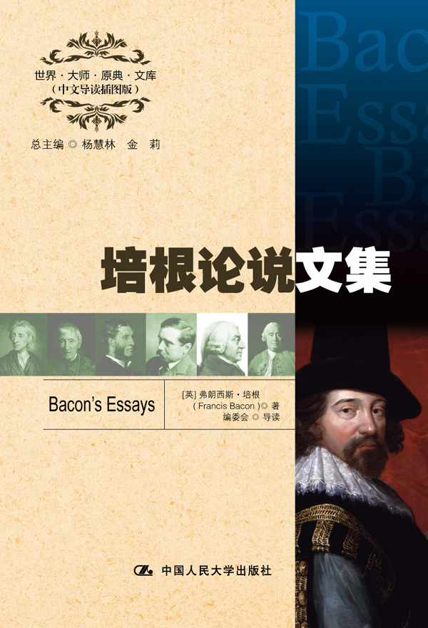

请插入封面
书号：978-7-300-16420-5
著者：[英] 弗朗西斯·培根 著
编委会 导读
责任编辑：鞠方安
成品：148*210 页数：229
纸张：70克轻型纸
装祯：平装
出版时间：2012年9月
定价：19.00元
出版社：中国人民大学出版社

- 本书卖点
- 《论说文集》是培根阅历、观点和思想的集中体现和浓缩
- 全面精彩的中文导读
- 学习英语的珍贵资料

◆ 读者定位
1．全国高等院校英语及相关专业学生
2. 高等院校非英语专业英语学习者及同等英语水平学习者
3. 广大外语教师
4. 哲学、文化、政治及法律等各领域的研究学者及学生

- 作者简介
弗朗西斯·培根（1561—1626），英国文艺复兴时期著名的哲学家、思想家和文化大师。培根生于贵族之家，阅历丰富。他一生在文学、哲学、科学、美学、伦理学、语言逻辑学等领域都有不凡的建树，是一位影响深远、多才多艺的大家。代表作主要有：《培根论说文集》、《学术的进展》、《新工具》、《亨利七世本纪》和《论人类的知识》等。
- 内容简介
《培根论说文集》收集了培根长达二十八年的间歇创作，涉及荣誉、财富、爱情、名声、雄心和友谊等人类生活和感情的各个方面，其精辟理智的见解和冷静雄犀的笔调使其成为人类文学史和思想史的重要著作，也是至今最出色和流传最广的人文作品之一。
◆ 简要目录
Introduction
To the Right Honorable my very good lord the Duke of Buckingham his Grace, Lord High Admiral of England
1 Of Studies
2 Of Truth
3 Of Death
4 Of Unity in Religion
5 Of Revenge
6 Of Adversity
7 Of Simulation & Dissimulation
8 Of Parents & Children
9 Of Marriage & Single Life
10 Of Envy
11 Of Love
12 Of Great Place
13 Of Boldness
14 Of Goodness, & Goodness of Nature
15 Of Nobility
16 Of Seditions & Troubles
17 Of Atheism
18 Of Superstition
19 Of Travel
20 Of Empire
21 Of Counsel
22 Of Delays
23 Of Cunning
24 Of Wisdom for a Man’s Self
25 Of Innovations
26 Of Dispatch
27 Of Seeming Wise
28 Of Friendship
29 Of Expense
30 Of the True Greatness of Kingdoms & Estates
31 Of Regiment of Health
32 Of Suspicion
33 Of Discourse
34 Of Plantations
35 Of Riches
36 Of Prophecies
37 Of Ambition
38 Of Masques & Triumphs
39 Of Nature in Men
40 Of Custom & Education
41 Of Fortune
42 Of Usury
43 Of Youth & Age
44 Of Beauty
45 Of Deformity
46 Of Building
47 Of Gardens
48 Of Negotiating
49 Of Followers & Friends
50 Of Suitors
51 Of Faction
52 Of Ceremonies & Respects
53 Of Praise
54 Of Vainglory
55 Of Honour & Reputation
56 Of Judicature
57 Of Anger
58 Of Vicissitude of Things
A Fragment of an Essay of Fame

◆ 重要书评

培根的《论说文集》可说是少数的‘世界书’的一部，这种书不是为一国而作，乃是为万国而作的；不是为一个时代，而是为一切时代的。
——奥利芬特·斯米顿

“培根是经验主义的奠基人。”
——黑格尔

“培根的哲学思想具有永恒的价值。”
——罗素

◆ 上架建议
外语/哲学/畅销书

书摘
Of Studies
Studies serve for delight, for ornament, and for ability. Their chief use for delight, is in privateness and retiring; for ornament, is in discourse; and for ability, is in the judgement and disposition of business. For expert men can execute, and perhaps judge of particulars, one by one; but the general counsels, and the plots, and marshalling of affairs, come best from those that are learned. To spend too much time in studies, is sloth; to use them too much for ornament, is affectation; to make judgement wholly by their rules is the humour of a scholar. They perfect nature, and are perfected by experience: for natural abilities are like natural plants, that need pruning by study: and studies themselves do give forth directions too much at large, except they be bounded in by experience. Crafty men condemn studies; simple men admire them; and wise men use them: for they teach not their own use; but that is a wisdom without them, and above them, won by observation. Read not to contradict, and confute; nor to believe and take for granted; nor to find talk and discourse; but to weigh and consider. Some books are to be tasted, others to be swallowed, and some few to be chewed and digested: that is, some books are to be read only in parts; others to be read but not curiously; and some few to be read wholly, and with diligence and attention. Some books also may be read by deputy, and extracts made of them by others: but that would be, only in the less important arguments, and the meaner sort of book: else distilled books are like common distilled waters, flashy things. Reading maketh a full man; conference a ready man; and writing an exact man. And therefore, if a man write little, he had need have a great memory; if he confer little, he had need have a present wit; and if he read little, he had need have much cunning, to seem to know that he doth not. Histories make men wise; poets witty; the mathematics subtle; natural philosophy deep; moral grave; logic and rhetoric able to contend. Abeunt studia in mores. Nay, there is no stond or impediment in the wit, but may be wrought out by fit studies: like as diseases of the body may have appropriate exercises. Bowling is good for the stone and reins; shooting for the lungs and breast; gentle walking for the stomach; riding for the head; and the like. So if a man’s wit be wandering, let him study the mathematics; for in demonstrations, if his wit be called away never so little, he must begin again: if his wit be not apt to distinguish or find differences, let him study the schoolmen; for they are cymini sectores. If he be not apt to beat over matters, and to call up one thing, to prove and illustrate another, let him study the lawyers’ cases: so every defect of the mind may have a special receipt.

