书名：人类理解论（上、下）
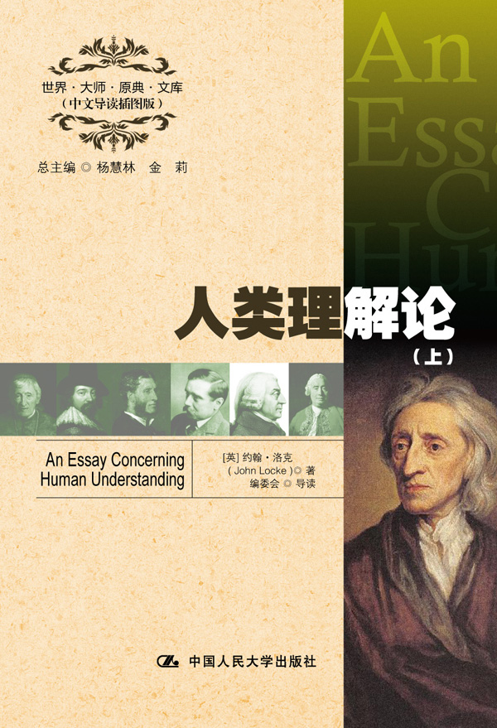

请插入封面
书号：978-7-300-16419-9
著者：[英] 约翰·洛克 著
编委会 导读
责任编辑：王琼
成品：148*210 页数：799
纸张：70克轻型纸
装祯：平装
出版时间：2012年9月
定价：（上、下）58.00元
出版社：中国人民大学出版社

- 本书卖点
- 全面精彩的中文导读
- 精美的插图
- 学习英语的珍贵资料

◆ 读者定位
1．全国高等院校英语及相关专业学生
2. 高等院校非英语专业英语学习者及同等英语水平学习者
3. 广大外语教师
4. 哲学、文化、政治及法律等各领域的研究学者及学生

- 作者简介
约翰•洛克（1632－1704），英国哲学家。在知识论上，洛克与大卫•休谟、乔治•贝克莱三人被列为英国经验主义的代表人物，但他也在社会契约理论上做出了重要贡献。他认为人民拥有生命、自由和财产的自然权利，人民有推翻政府的权利。洛克的思想对于后代政治哲学的发展产生巨大影响，并且被广泛视为是启蒙时代最具影响力的思想家和自由主义者。
- 内容简介
《人性理解论》是英国经验论哲学的代表作。洛克对真理的执着、以事实为据、对情感持疑以及他的忍耐力都在这部著作中表现得十分明显。在书中，洛克提出了第一性的质与第二性的质、简单观念与复杂观念的学说，论述了知识的本性、形成、等级和范围等问题。

◆ 简要目录
Chronology
The Epistle Dedicatory
The Epistle to the Reader
BOOK I: Of Innate Notions
Chapter
I Introduction
II No Innate Principles in the Mind
III No Innate Practical Principles
IV Other Considerations concerning Innate Principles, both Speculative and Practical
BOOK II: Of Ideas
Chapter
I Of Ideas in General, and their Original
II Of Simple Ideas
III Of Ideas of One Sense
IV Of Solidity
V Of Simple Ideas of Divers Senses
VI Of Simple Ideas of Reflection
VII Of Simple Ideas of both Sensation and Reflection
VIII Some further Considerations concerning our Simple Ideas
IX Of Perception
X Of Retention
XI Of Discerning, and other Operations of the Mind
XII Of Complex Ideas
XIII Of Simple Modes; and first, of the Simple Modes of Space
XIV Of Duration, and its Simple Modes
XV Of Duration and Expansion, considered together
XVI Of Number
XVII Of Infinity
XVIII Of other Simple Modes
XIX Of the Modes of Thinking
XX Of Modes of Pleasure and Pain
XXI Of Power
XXII Of Mixed Modes
XXIII Of our Complex Ideas of Substances
XXIV Of Collective Ideas of Substances
XXV Of Relation
XXVI Of Cause and Effect, and other Relations
XXVII Of Identity and Diversity
XXVIII Of Other Relations
XXIX Of Clear and Obscure, Distinct and Confused Ideas
XXX Of Real and Fantastical Ideas
XXXI Of Adequate and Inadequate Ideas
XXXII Of True and False Ideas
XXXIII Of the Association of Ideas

◆ 上架建议
外语/哲学/畅销书

书摘
Chapter I
Introduction
§1. An inquiry into the understanding, pleasant and useful. Since ’tis the understanding that sets man above the rest of sensible beings, and gives him all the advantage and dominion, which he has over them; ’tis certainly a subject, even for its nobleness, worth our labour to inquire into. The understanding, like the eye, whilst it makes us see and perceive all other things, takes no notice of itself: and it requires art and pains to set it at a distance, and make it its own object. But whatever be the difficulties, that lie in the way of this inquiry; whatever it be, that keeps us so much in the dark to ourselves; sure I am, that all the light we can let in upon our own minds; all the acquaintance we can make with our own understandings, will not only be very pleasant, but bring us great advantage, in directing our thoughts in the search of other things.
§2. Design. This, therefore, being my purpose to inquire into the original, certainty, and extent of human knowledge; together with the grounds and degrees of belief, opinion, and assent; I shall not at present meddle with the physical consideration of the mind; or trouble myself to examine, wherein its essence consists, or by what motions of our spirits, or alterations of our bodies, we come to have any sensation by our organs, or any ideas in our understandings; and whether those ideas do in their formation, any, or all of them, depend on matter or not. These are speculations, which, however curious and entertaining, I shall decline, as lying out of my way, in the design I am now upon. It shall suffice to my present purpose, to consider the discerning faculties of a man, as they are employed about the objects, which they have to do with: and I shall imagine I have not wholly misemployed myself in the thoughts I shall have on this occasion, if, in this historical, plain method, I can give any account of the ways, whereby our understandings come to attain those notions of things we have, and can set down any measures of the certainty of our knowledge, or the grounds of those persuasions, which are to be found amongst men, so various, different, and wholly contradictory; and yet asserted somewhere or other with such assurance, and confidence, that he that shall take a view of the opinions of mankind, observe their opposition, and at the same time, consider the fondness, and devotion wherewith they are embraced; the resolution and eagerness, wherewith they are maintained, may perhaps have reason to suspect, that either there is no such thing
as truth at all; or that mankind hath no sufficient means to attain a certain knowledge of it.
§3. Method. ’tis therefore worth while, to search out the bounds between opinion and knowledge; and examine by what measures, in things, whereof we have no certain knowledge, we ought to regulate our assent, and moderate our persuasion. In order whereunto, I shall pursue this following method.
First, I shall inquire into the original of those ideas, notions, or whatever else you please to call them, which a man observes, and is conscious to himself he has in his mind; and the ways whereby the understanding comes to be furnished with them.
Secondly, I shall endeavour to show, what knowledge the understanding hath by those ideas; and the certainty, evidence, and extent of it.
Thirdly, I shall make some inquiry into the nature and grounds of faith, or opinion; whereby I mean that assent, which we give to any proposition as true, of whose truth yet we have no certain knowledge: and here we shall have occasion to examine the reasons and degrees of assent.

