书名：文化与无政府状态
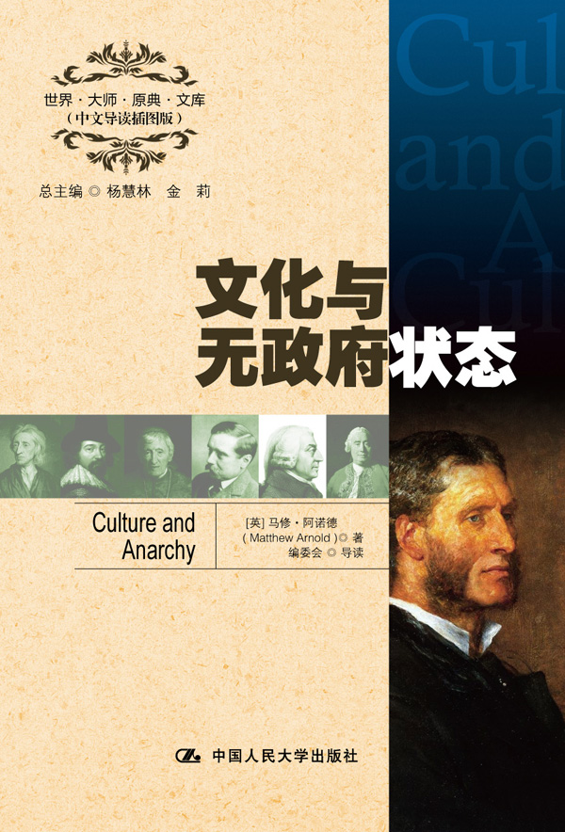

请插入封面
书号：978-7-300-16417-5
著者：[英] 马修·阿诺德 著
编委会 导读
责任编辑：李楠
成品：148*210 页数：206
纸张：70克轻型纸
装祯：平装
出版时间：2012年9月
定价：23.00元
出版社：中国人民大学出版社

- 本书卖点
- 马修·阿诺德对于文化的独到见解
- 全面精彩的中文导读
- 学习英语的珍贵资料

◆ 读者定位
1．全国高等院校英语及相关专业学生
2. 高等院校非英语专业英语学习者及同等英语水平学习者
3. 广大外语教师
4. 哲学、文化、政治及法律等各领域的研究学者及学生

- 作者简介
马修·阿诺德（1822—1888），英国近代诗人、教育家，评论家。出生于教师家庭，是拉格比公学校长、托马斯·阿诺德之子。阿诺德曾任牛津大学诗学教授(1857—1867)。阿诺德对文化的功能和作用有独到的研究，影响深远，享有“文化使徒”和“文化斗士”的美誉。在诗学方面，主张诗要反映时代的要求，需有追求道德和智力“解放”的精神。其诗歌和评论针砭时弊，富有理性。

- 内容简介
《文化与无政府状态》一书中，作者把维多利亚时代的英国人分称为野蛮人（贵族）、非利士人（中产阶级）和群氓（平民），严厉抨击了他们的自满、庸俗和拜金主义，倡导以美与智的文化。通过阅读、观察和思考通向天道和神的意旨来对抗随心所欲、我行我素的个人主义与工业主义所导致的缺乏秩序、准则和方向感的无政府状态，以期实现“文化、人性整体和谐、全面发展的完美”，从而确立国家的观念、集体的最优秀的自我，和民族的健全理智。

◆ 简要目录
Preface
Introduction
Chapter I
Chapter II
Chapter III
Chapter IV
Chapter V
Chapter VI
Conclusion

◆ 上架建议
外语/哲学/畅销书

书摘
Chapter I
The disparagers of culture make its motive curiosity; sometimes, indeed, they make its motive mere exclusiveness and vanity. The culture which is supposed to plume itself on a smattering of Greek and Latin is a culture which is begotten by nothing so intellectual as curiosity; it is valued either out of sheer vanity and ignorance, or else as an engine of social and class distinction, separating its holder, like a badge or title, from other people who have not got it. No serious man would call this culture, or attach any value to it, as culture, at all. To find the real ground for the very differing estimate which serious people will set upon culture, we must find some motive for culture in the terms of which may lie a real ambiguity; and such a motive the word curiosity gives us. I have before now pointed out that in English we do not, like the foreigners, use this word in a good sense as well as in a bad sense; with us the word is always used in a somewhat disapproving sense; a liberal and intelligent eagerness about the things of the mind may be meant by a foreigner when he speaks of curiosity, but with us the word always conveys a certain notion of frivolous and unedifying activity. In the Quarterly Review, some little time ago, was an estimate of the celebrated French critic, Monsieur Sainte-Beuve, and a very inadequate estimate it, in my judgment, was. And its inadequacy consisted chiefly in this: that in our English way it left out of sight the double sense really involved in the word curiosity, thinking enough was said to stamp Monsieur Sainte-Beuve with blame if it was said that he was impelled in his operations as a critic by curiosity, and omitting either to perceive that Monsieur Sainte-Beuve himself, and many other people with him, would consider that this was praiseworthy and not blameworthy, or to point out why it ought really to be accounted worthy of blame and not of praise. For as there is a curiosity about intellectual matters which is futile, and merely a disease, so there is certainly a curiosity, –– a desire after the things of the mind simply for their own sakes and for the pleasure of seeing them as they are, –– which is, in an intelligent being, natural and laudable. Nay, and the very desire to see things as they are implies a balance and regulation of mind which is not often attained without fruitful effort, and which is the very opposite of the blind and diseased impulse of mind which is what we mean to blame when we blame curiosity. Montesquieu says: –– “The first motive which ought to impel us to study is the desire to augment the excellence of our nature, and to render an intelligent being yet more intelligent.” This is the true ground to assign for the genuine scientific passion, however manifested, and for culture, viewed simply as a fruit of this passion; and it is a worthy ground, even though we let the term curiosity stand to describe it.
But there is of culture another view, in which not solely the scientific passion, the sheer desire to see things as they are, natural and proper in an intelligent being, appears as the ground of it. There is a view in which all the love of our neighbour, the impulses towards action, help, and beneficence, the desire for stopping human error, clearing human confusion, and diminishing the sum of human misery, the noble aspiration to leave the world better and happier than we found it, –– motives eminently such as are called social, –– come in as part of the grounds of culture, and the main and preeminent part. Culture is then properly described not as having its origin in curiosity, but as having its origin in the love of perfection; it is a study of perfection. It moves by the force, not merely or primarily of the scientific passion for pure knowledge, but also of the moral and social passion for doing good. As, in the first view of it, we took for its worthy motto Montesquieu’s words: “To render an intelligent being yet more intelligent!” so, in the second view of it, there is no better motto which it can have than these words of Bishop Wilson: “To make reason and the will of God prevail!” Only, whereas the passion for doing good is apt to be overhasty in determining what reason and the will of God say, because its turn is for acting rather than thinking, and it wants to be beginning to act; and whereas it is apt to take its own conceptions, which proceed from its own state of development and share in all the imperfections and immaturities of this, for a basis of action; what distinguishes culture is, that it is possessed by the scientific passion, as well as by the passion of doing good; that it has worthy notions of reason and the will of God, and does not readily suffer its own crude conceptions to substitute themselves for them; and that, knowing that no action or institution can be salutary and stable which are not based on reason and the will of God, it is not so bent on acting and instituting, even with the great aim of diminishing human error and misery ever before its thoughts, but that it can remember that acting and instituting are of little use, unless we know how and what we ought to act and to institute.

