书名（中文）：公共演讲的艺术（第七版）
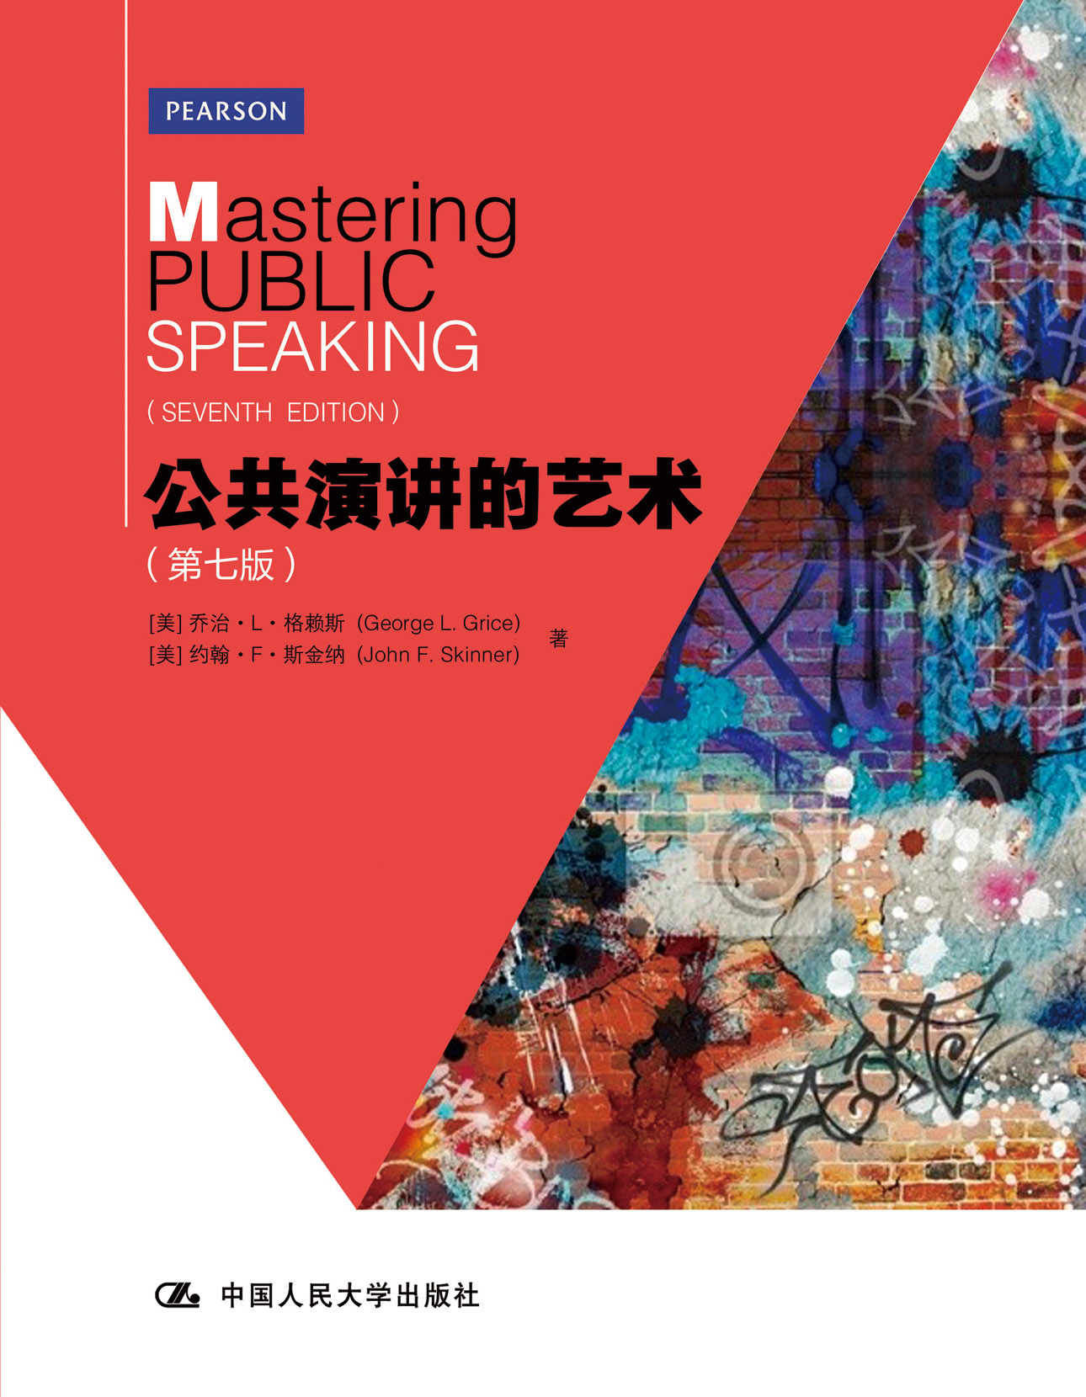

请插入封面
（英文）：Mastering Public Speaking （Seventh Edition）
书号：978-7-300-16480-9
著者：乔治•L•格赖斯 (George L. Grice),
约翰•F•斯金纳 (John F. Skinner)
责任编辑：王昱
成品：215*275 页数：412
纸张：70克胶版纸
装祯：平装
出版时间：2012年11月
定价：49.00元
出版社：中国人民大学出版社

- 本书卖点
- 再版多次，公共演讲领域的畅销书
- 作者公共演讲方面的经典之作
- 章节设计合理，理论论述与案例讲解相结合
- 内容循序渐进，便于教师教学和学习者自学
- 精选多篇古今经典英语演讲，制作成光盘，供学习者欣赏

◆ 读者定位
1．全国高等院校英语及相关专业学生
2. 高等院校非英语专业英语学习者及同等英语水平学习者
3. 广大外语教师
4. 演讲爱好者

- 作者简介
乔治•L•格赖斯 (George L. Grice)，现为美国罗德福德大学教授，是当代演讲和交流艺术领域的国际知名学者。主要著作有《Mastering Public Speaking》和《Business and Professional Communications: Selected Readings》。
约翰•F•斯金纳 (John F. Skinner)，美国教授， 多年从事演讲教学，同时也参与了《Mastering Public Speaking》一书前几版的编写。

- 内容简介
《公共演讲的艺术》(第七版) 一书从演讲的分类，演讲的规划和准备，演讲的技巧和内容等多个方面全面介绍了公共演讲这门课程，同时突出强调演讲中的道德准则与思辨能力。本书语言活地道，内容细致全面。学习者在掌握公共演讲艺术理论与实践的同时，还可以充分学习、领略和欣赏英语这门语言。
◆ 简要目录
Chapter1 An Introduction to Public Speaking
Chapter2 The Ethics of Public Speaking
Chapter3 Speaking Confidently
Chapter4 Responding to Speeches
Chapter5 Analyzing Your Audience
Chapter6 Selecting Your Speech Topic
Chapter7 Researching Your Topic
Chapter8 Supporting Your Speech
Chapter9 Organizing the Body of Your Speech
Chapter10 Introducing and Concluding Your Speech
Chapter11 Outlining Your Speech
Chapter12 Wording Your Speech
Chapter13 Delivering Your Speech
Chapter14 Using Presentational Aids
Chapter15 Speaking to Inform
Chapter16 The Strategy of Persuasion
Chapter17 The Structure of Persuasion
Chapter18 Speaking to Special Occasions
Chapter19 Speaking in and as a Group
◆ 上架建议
外语 /畅销书

书摘
Preface to the Instructor
Our goal is to empower students to take responsibility for their own learning by challenging them to make all the decisions required of public speakers. By incorporating into our text many credible examples, both actual and hypothetical, we hoped to inspire and encourage students to achieve the full potential of public speech… We seek to engage students in the principles, practice, and ethics of public speaking—both as speakers and as listeners.

Chapter 12
English speakers have access to the richest vocabulary on Earth, largely because we have adopted words so freely from other languages. In fact, three out of five words in English come from a foreign tongue. As a result, the revised Oxford English Dictionary is huge, containing 615,000 words. This is more than three times as many words as the German language contains and more than six times the number of words available to the French. People who speak English can achieve degrees of subtlety and nuance that are impossible in most languages. So you would think we could manage to be clearer than the speakers and writers in the chapter opening operations.
Socrates died of an overdose of hemlock, not wedlock. We doubt that those sisters had to wait in the supermarket checkout line for 18 years, even if there were lots of double-coupon days!

