书名：联邦党人文集（上、下）
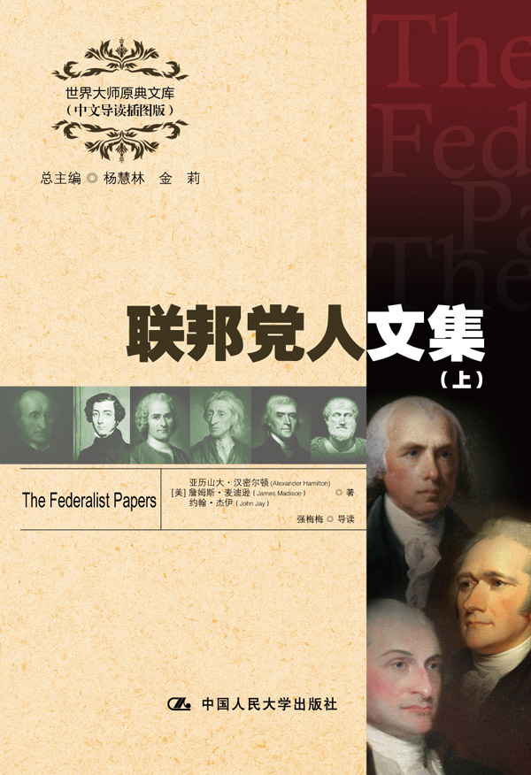插入封面
书号：978-7-300-17226-2
著者：[美] 亚历山大·汉密尔顿
詹姆斯·麦迪逊
约翰·杰伊 著
强梅梅 导读
责任编辑：王昱
成品：148*210 页数：698
纸张：70克高白胶
装祯：平装
出版时间：2013年4月
定价：（上、下）49.00元
出版社：中国人民大学出版社

- 本书卖点
- 美国宪法的理论来源
- 全面、精彩、详实的中文导读
- 学习英语的珍贵资料

◆ 读者定位
1．全国高等院校英语及相关专业学生
2. 高等院校非英语专业英语学习者及同等英语水平学习者
3. 广大外语教师
4. 哲学、文化、政治及法律等各领域的研究学者及学生

- 作者简介
亚历山大•汉密尔顿（1757—1804），美国开国元勋之一，宪法起草人之一，财经专家，美国第一任财政部长。是美国政党制度的创建者，在美国金融、财政和工业发展史上占有重要地位。因政党相争而决斗丧生。2006年，汉密尔顿被美国的权威期刊《大西洋月刊》评为影响美国的100位人物第5名。
约翰•杰伊（1745—1829），美国政治家、革命家、外交家和法学家。他与本杰明•富兰克林和约翰•亚当斯一同出使法国、与亚历山大•汉密尔顿和詹姆斯•麦迪逊一起撰写了《联邦党人文集》。他还曾任美国最高法院法官，从1789年到1795年他出任美国首席大法官。1829年逝世于纽约威切斯特郡。
詹姆斯•麦迪逊（1751—1836），美国第四任总统。他担任总统期间曾领导进行第二次美英战争，保卫了美国的共和制度，为美国赢得彻底独立建立了功绩。他在1776年参加弗吉尼亚宪法的制定，是弗吉尼亚会议的领导人。他还是出席大陆会议的代表、制宪会议的主要人物、北部联邦党人文件的起草人之一、众议院议员、民主共和党的组织者。
- 内容简介
《联邦党人文集》是亚历山大•汉密尔顿、约翰•杰伊、和詹姆斯•麦迪逊三人为争取批准新宪法在纽约报刊上共以“普布利乌斯”为笔名而发表的一系列的论文文集。1787年费城举行的全国代表会议制定了一部新宪法。但是，在各州的批准过程中，对新宪法有两种截然相反的意见：一种拥护，一种反对。因此就发生了美国历史上一场最激烈的论战。本书就是这次论战的产物。
◆ 简要目录
FEDERALIST No. 1 General Introduction
FEDERALIST No. 2 Concerning Dangers from Foreign Force and Influence
FEDERALIST No. 3 The Same Subject Continued
FEDERALIST No. 4 The Same Subject Continued
FEDERALIST No. 5 The Same Subject Continued
FEDERALIST No. 6 Concerning Dangers from Dissensions Between the States
FEDERALIST No. 7 The Same Subject Continued
FEDERALIST No. 8 The Consequences of Hostilities Between the States
FEDERALIST No. 9 The Union as a Safeguard Against Domestic Faction and Insurrection
FEDERALIST No. 10 The Same Subject Continued
FEDERALIST No. 11 The Utility of the Union in Respect to Commercial Relations and a Navy
FEDERALIST No. 12 The Utility of the Union in Respect to Revenue
FEDERALIST No. 13 Advantage of the Union in Respect to Economy in Government
FEDERALIST No. 14 Objections to the Proposed Constitution from Extent of Territory Answered
FEDERALIST No. 15 The Insufficiency of the Present Confederation to Preserve the Union
FEDERALIST No. 16 The Same Subject Continued
FEDERALIST No. 17 The Same Subject Continued
FEDERALIST No. 18 The Same Subject Continued
FEDERALIST No. 19 The Same Subject Continued
FEDERALIST No. 20 The Same Subject Continued
FEDERALIST No. 21 Other Defects of the Present Confederation
FEDERALIST No. 22 The Same Subject Continued
FEDERALIST No. 23 The Necessity of a Government as Energetic as the One Proposed to the Preservation of the Union
FEDERALIST No. 24 The Powers Necessary to the Common Defense Further Considered
FEDERALIST No. 25 The Same Subject Continued
FEDERALIST No. 26 The Idea of Restraining the Legislative Authority in Regard to the Common Defense Considered
FEDERALIST No. 27 The Same Subject Continued
FEDERALIST No. 28 The Same Subject Continued
FEDERALIST No. 29 Concerning the Militia
FEDERALIST No. 30 Concerning the General Power of Taxation
FEDERALIST No. 31 The Same Subject Continued
FEDERALIST No. 32 The Same Subject Continued
FEDERALIST No. 33 The Same Subject Continued
FEDERALIST No. 34 The Same Subject Continued
FEDERALIST No. 35 The Same Subject Continued
FEDERALIST No. 36 The Same Subject Continued
FEDERALIST No. 37 Concerning the Difficulties of the Convention in Devising a Proper Form of Government
FEDERALIST No. 38 The Same Subject Continued, and the Incoherence of the Objections to the New Plan Exposed
FEDERALIST No. 39 The Conformity of the Plant to Republican Principles
FEDERALIST No. 40 On the Powers of the Convention to Form a Mixed Government Examined and Sustained
FEDERALIST No. 41 General View of the Powers Conferred by the Constitution
FEDERALIST No. 42 The Powers Conferred by the Constitution Further Considered
FEDERALIST No. 43 The Same Subject Continued
FEDERALIST No. 44 Restrictions on the Authority of the Several States
FEDERALIST No. 45 The Alleged Danger from the Powers of the Union to the State Governments Considered
FEDERALIST No. 46 The Influence of the State and Federal Governments Compared
FEDERALIST No. 47 The Particular Structure of the New Government and the Distribution of Power Among Its Different Parts
FEDERALIST No. 48 These Departments Should Not Be So Far Separated as to Have No Constitutional Control over Each Other
FEDERALIST No. 49 Method of Guarding Against the Encroachments of Any One Department of Government by Appealing to the People Through a Convention
FEDERALIST No. 50 Periodical Appeals to the People Considered
FEDERALIST No. 51 The Structure of the Government Must Furnish the Proper Checks and Balances Between the Different Departments
FEDERALIST No. 52 The House of Representatives
FEDERALIST No. 53 The Same Subject Continued
FEDERALIST No. 54 The Apportionment of Members Among the States
FEDERALIST No. 55 The Total Number of the House of Representatives
FEDERALIST No. 56 The Same Subject Continued
FEDERALIST No. 57 The Alleged Tendency of the New Plan to Elevate the Few at the Expense of the Many Considered in Connection with Representation
FEDERALIST No. 58 Objection That the Number of Members Will Not Be Augmented as the Progress of Population Demands Considered
FEDERALIST No. 59 Concerning the Power of Congress to Regulate the Election of Members
FEDERALIST No. 60 The Same Subject Continued
FEDERALIST No. 61 The Same Subject Continued
FEDERALIST No. 62 The Senate
FEDERALIST No. 63 The Senate Continued
FEDERALIST No. 64 The Powers of the Senate
FEDERALIST No. 65 The Powers of the Senate Continued
FEDERALIST No. 66 Objections to the Power of the Senate to Set as a Court for Impeachments Further Considered
FEDERALIST No. 67 The Executive Department
FEDERALIST No. 68 The Mode of Electing the President
FEDERALIST No. 69 The Real Character of the Executive
FEDERALIST No. 70 The Executive Department Further Considered
FEDERALIST No. 71 The Duration in Office of the Executive
FEDERALIST No. 72 The Same Subject Continued, and Re-Eligibility of the Executive Considered
FEDERALIST No. 73 The Provision for the Support of the Executive, and the Veto Power
FEDERALIST No. 74 The Command of the Military and Naval Forces, and the Pardoning Power of the Executive
FEDERALIST No. 75 The Treaty-Making Power of the Executive
FEDERALIST No. 76 The Appointing Power of the Executive
FEDERALIST No. 77 The Appointing Power Continued and Other Powers of the Executive Considered
FEDERALIST No. 78 The Judiciary Department
FEDERALIST No. 79 The Judiciary Continued
FEDERALIST No. 80 The Powers of the Judiciary
FEDERALIST No. 81 The Judiciary Continued, and the Distribution of the Judicial Authority
FEDERALIST No. 82 The Judiciary Continued
FEDERALIST No. 83 The Judiciary Continued in Relation to Trial by Jury
FEDERALIST No. 84 Certain General and Miscellaneous Objections to the Constitution Considered and Answered
FEDERALIST No. 85 Concluding Remarks
Appendixes
The Declaration of Independence
The Articles of Confederation
The Constitution of The United States of America
◆ 上架建议
外语/哲学/政治/畅销书

书摘
To the People of the State of New York:
IT IS not a new observation that the people of any country (if,like the Americans, intelligent and well-informed) seldom adopt and steadily persevere for many years in an erroneous opinion respecting their interests. That consideration naturally tends to create great respect for the high opinion which the people of America have so long and uniformly entertained of the importance of their continuing firmly united under one federal government, vested with sufficient powers for all general and national purposes.
The more attentively I consider and investigate the reasons which appear to have given birth to this opinion, the more I become convinced that they are cogent and conclusive.
Among the many objects to which a wise and free people find it necessary to direct their attention, that of providing for their safety seems to be the first. The safety of the people doubtless has relation to a great variety of circumstances and considerations, and consequently affords great latitude to those who wish to define it precisely and comprehensively.
At present I mean only to consider it as it respects security for the preservation of peace and tranquillity, as well as against dangers from foreign arms and influence, as from dangers of the like kind arising from domestic causes. As the former of these comes first in order, it is proper it should be the first discussed. Let us therefore proceed to examine whether the people are not right in their opinion that a cordial Union, under an efficient national government, affords them the best security that can be devised against hostilities from abroad.
The number of wars which have happened or will happen in the world will always be found to be in proportion to the number and weight of the causes, whether real or pretended, which provoke or invite them. If this remark be just, it becomes useful to inquire whether so many just causes of war are likely to be given by united America as by disunited America; for if it should turn out that united America will probably give the fewest, then it will follow that in this respect the Union tends most to preserve the people in a state of peace with other nations.
The just causes of war, for the most part, arise either from violation of treaties or from direct violence. America has already formed treaties with no less than six foreign nations, and all of them, except Prussia, are maritime, and therefore able to annoy and injure us. She has also extensive commerce with Portugal, Spain, and Britain, and, with respect to the two latter, has, in addition, the circumstance of neighborhood to attend to.
It is of high importance to the peace of America that she observe the laws of nations towards all these powers, and to me it appears evident that this will be more perfectly and punctually done by one national government than it could be either by thirteen separate States or by three or four distinct confederacies. For this opinion various reasons may be assigned.

