书名：社会契约论
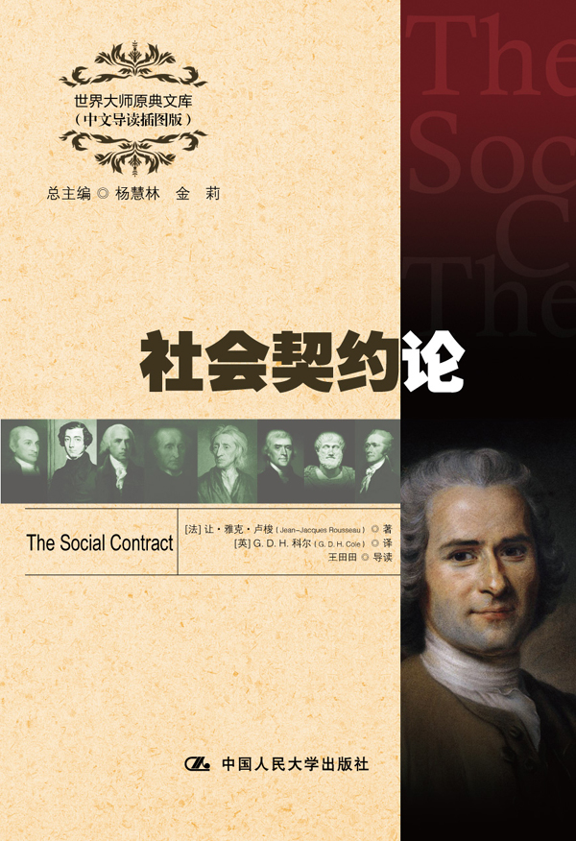

请插入封面
书号：978-7-300-17227-9
著者：[法] 让·雅克·卢梭 著
[英] G. D. H. 科尔 译
王田田 导读
责任编辑：王昱
成品：148*210 页数：212
纸张：70克高白胶
装祯：平装
出版时间：2013年4月
定价：23.00元
出版社：中国人民大学出版社

- 本书卖点
- 卢梭最为深刻和成熟的政治理论著作
- 政治学史上最经典的文献之一
- 全面、精彩、详实的中文导读
- 学习英语的珍贵资料

◆ 读者定位
1．全国高等院校英语及相关专业学生
2. 高等院校非英语专业英语学习者及同等英语水平学习者
3. 广大外语教师
4. 哲学、文化、政治及法律等各领域的研究学者及学生

- 作者简介
让•雅克•卢梭 （1712—1778），法国伟大的启蒙思想家、哲学家、教育家、文学家，是18世纪法国大革命的思想先驱，启蒙运动最卓越的代表人物之一。主要著作有《社会契约论》、《论人类不平等的起源和基础》、《爱弥儿》、《忏悔录》、《新爱洛漪丝》等。

- 内容简介
《社会契约论》是一部政治哲学著作，主要探讨政治权利的原理，主旨是为人民民主主权的建立奠定理论基础。社会契约论分为四卷。第一卷论述社会结构和社会契约；第二卷阐述主权及其权利；第三卷阐述政府及其运作形式；第四卷讨论几种社会组织。书中主权在民的思想，是现代民主制度的基石，美国的《独立宣言》和法国的《人权宣言》及两国的宪法均体现了《社会契约论》的民主思想。
◆ 简要目录
FOREWARD
第一卷导读
BOOK I
1. SUBJECT OF THE FIRST BOOK
2. THE FIRST SOCIETIES
3. THE RIGHT OF THE STRONGEST
4. SLAVERY
5. THAT WE MUST ALWAYS GO BACK TO A FIRST CONVENTION
6. THE SOCIAL COMPACT
7. THE SOVEREIGN
8. THE CIVIL STATE
9. REAL PROPERTY
第二卷导读
BOOK Ⅱ
1. THAT SOVEREIGNTY IS INALIENABLE
2. THAT SOVEREIGNTY IS INDIVISIBLE
3. WHETHER THE GENERAL WILL IS FALLIBLE
4. THE LIMITS OF THE SOVEREIGN POWER
5. THE RIGHT OF LIFE AND DEATH
6. LAW
7. THE LEGISLATOR
8. THE PEOPLE
9. THE PEOPLE (continued)
10. THE PEOPLE (continued）
11. THE VARIOUS SYSTEMS OF LEGISLATION
12. THE DIVISION OF THE LAWS
第三卷导读
BOOK Ⅲ
1. GOVERNMENT IN GENERAL
2. THE CONSTITUENT PRINCIPLE IN THE VARIOUS FORMS OF GOVERNMENT
3. THE DIVISION OF GOVERNMENTS
4. DEMOCRACY
5. ARISTOCRACY
6. MONARCHY
7. MIXED GOVERNMENTS
8. THAT ALL FORMS OF GOVERNMENT DO NOT SUIT ALL COUNTRIES
9. THE MARKS OF A GOOD GOVERNMENT
10. THE ABUSE OF GOVERNMENT AND ITS TENDENCY TO DEGENERATE
11. THE DEATH OF THE BODY POLITIC
12. HOW THE SOVEREIGN AUTHORITY MAINTAINS
ITSELF
13. THE SAME (continued）
14. THE SAME (continued)
15. DEPUTIES OR REPRESENTATIVES
16. THAT THE INSTITUTION OF GOVERNMENT IS NOT A
CONTRACT
17. THE INSTITUTION OF GOVERNMENT
18. HOW TO CHECK THE USURPATIONS OF GOVERNMENT
第四卷导读
BOOK Ⅳ
1. THAT THE GENERAL WILL IS INDESTRUCTIBLE
2. VOTING
3. ELECTIONS
4. THE ROMAN COMITIA
5. THE TRIBUNATE
6. THE DICTATORSHIP
7. THE CENSORSHIP
8. CIVIL RELIGION
9. CONCLUSION
◆ 上架建议
外语/哲学/政治/畅销书

书摘
BOOK Ⅰ
I MEAN to inquire if, in the civil order, there can be any sure and legitimate rule of administration, men being taken as they are and laws as they might be. In this inquiry I shall endeavour always to unite what right sanctions with what is prescribed by interest, in order that justice and utility may in no case be divided.
I enter upon my task without proving the importance of the subject. I shall be asked if I am a prince or a legislator, to write on politics. I answer that I am neither, and that is why I do so. If I were a prince or a legislator, I should not waste time in saying what wants doing; I should do it, or hold my peace.
As I was born a citizen ① of a free State, and a member of the Sovereign, I feel that, however feeble the influence my voice can have on public affairs, the right of voting on them makes it my duty to study them: and I am happy, when I reflect upon governments, to find my inquiries always furnish me with new reasons for loving that of my own country.
1. SUBJECT OF THE FIRST BOOK
MAN is born free; and everywhere he is in chains. One thinks himself the master of others, and still remains a greater slave than they. How did this change come about? I do not know. What can make it legitimate? That question I think I can answer.
If I took into account only force, and the effects derived from it, I should say: “As long as a people is compelled to obey, and obeys, it does well; as soon as it can shake off the yoke, and shakes it off, it does still better; for, regaining its liberty by the same right as took it away, either it is justified in resuming it, or there was no justification for those who took it away.” But the social order is a sacred right which is the basis of all other rights. Nevertheless, this right does not come from nature, and must therefore be founded on conventions. Before coming to that, I have to prove what I have just asserted.
2. THE FIRST SOCIETIES
THE most ancient of all societies, and the only one that is natural, is the family: and even so the children remain attached to the father only so long as they need him for their preservation. As soon as this need ceases, the natural bond is dissolved. The children, released from the obedience they owed to the father, and the father, released from the care he owed his children, return equally to independence. If they remain united, they continue so no longer naturally, but voluntarily; and the family itself is then maintained only by convention.
This common liberty results from the nature of man. His first law is to provide for his own preservation, his first cares are those which he owes to himself; and, as soon as he reaches years of discretion, he is the sole judge of the proper means of preserving himself, and consequently becomes his own master.
The family then may be called the first model of political societies: the ruler corresponds to the father, and the people to the children; and all, being born free and equal, alienate their liberty only for their own advantage. The whole difference is that, in the family, the love of the father for his children repays him for the care he takes of them, while, in the State, the pleasure of commanding takes the place of the love which the chief cannot have for the peoples under him.
Grotius denies that all human power is established in favour of the governed, and quotes slavery as an example . His usual method of reasoning is constantly to establish right by fact.1 It would be possible to employ a more logical method, but none could be more favourable to tyrants.
It is then, according to Grotius, doubtful whether the human race belongs to a hundred men, or that hundred men to the human race: and, throughout his book, he seems to incline to the former alternative, which is also the view of Hobbes. On this showing, the human species is divided into so many herds of cattle, each with its ruler, who keeps guard over them for the purpose of devouring them.
As a shepherd is of a nature superior to that of his flock, the shepherds of men, i.e., their rulers, are of a nature superior to that of the peoples under them. Thus, Philo tells us, the Emperor Caligula reasoned, concluding equally well either that kings were gods, or that men were beasts.
The reasoning of Caligula agrees with that of Hobbes and Grotius. Aristotle, before any of them, had said that men are by no means equal naturally, but that some are born for slavery, and others for dominion.
Aristotle was right; but he took the effect for the cause. Nothing can be more certain than that every man born in slavery is born for slavery. Slaves lose everything in their chains, even the desire of escaping from them: they love their servitude, as the comrades of Ulysses loved their brutish condition. If then there are slaves by nature, it is because there have been slaves against nature. Force made the first slaves, and their cowardice perpetuated the condition.
I have said nothing of King Adam , or Emperor Noah , father of the three great monarchs who shared out the universe, like the children of Saturn, whom some scholars have recognised in them.
I trust to getting due thanks for my moderation; for, being a direct descendant of one of these princes, perhaps of the eldest branch, how do I know that a verification of titles might not leave me the legitimate king of the human race? In any case, there can be no doubt that Adam was sovereign of the world, as Robinson Crusoe was of his island, as long as he was its only inhabitant; and this empire had the advantage that the monarch, safe on his throne, had no rebellions, wars, or conspirators to fear.

