书名：政府论（下篇）

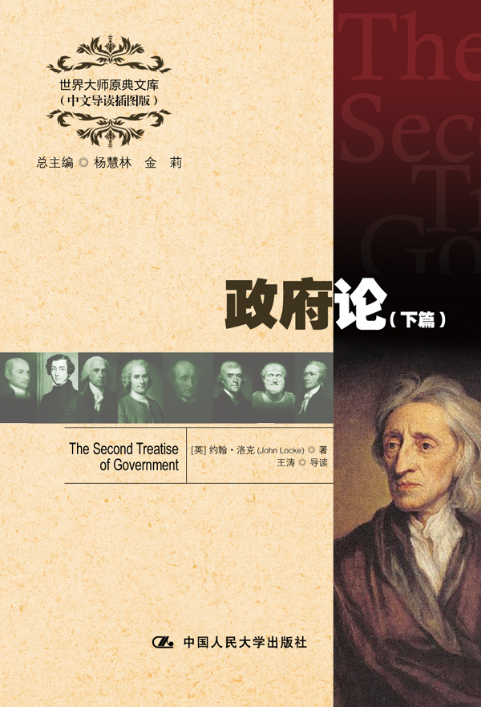
请插入封面
书号：978-7-300-17228-6
著者：[英] 约翰·洛克 著
王涛 导读
责任编辑：李楠
成品：148*210 页数：275
纸张：70克高白胶
装祯：平装
出版时间：2013年4月
定价：25.00元
出版社：中国人民大学出版社

- 本书卖点
- 西方政治学的不朽名著
- 以通俗易懂的语言阐述简明有力的政治论断
- 全面、精彩、详实的中文导读
- 学习英语的珍贵资料

◆ 读者定位
1．全国高等院校英语及相关专业学生
2. 高等院校非英语专业英语学习者及同等英语水平学习者
3. 广大外语教师
4. 哲学、文化、政治及法律等各领域的研究学者及学生

- 作者简介
约翰•洛克（1632－1704），英国哲学家。在知识论上，洛克与大卫•休谟、乔治•贝克莱三人被列为英国经验主义的代表人物，但他也在社会契约理论上做出了重要贡献。他认为人民拥有生命、自由和财产的自然权利，人民有推翻政府的权利。洛克的思想对于后代政治哲学的发展产生巨大影响，并且被广泛视为是启蒙时代最具影响力的思想家和自由主义者。

- 内容简介
《政府论（下篇）》阐释了洛克的政治思想，提出统治者的权力应来自于被统治者的同意，建立国家的唯一目的，乃是为了保障社会的安全以及人民的自然权利。该书一经出版立即引起了轰动。
◆ 简要目录
Preface
Chapter Ⅰ Introduction
Chapter Ⅱ Of the State of Nature
Chapter Ⅲ Of the State of War
Chapter Ⅳ Of Slavery
Chapter Ⅴ Of Property
Chapter Ⅵ Of Paternal Power
Chapter Ⅶ Of Political or Civil Society
Chapter Ⅷ Of the Beginning of Political Societies
Chapter Ⅸ Of the Ends of Political Society and Government
Chapter Ⅹ Of the Forms of a Commonwealth
Chapter Ⅺ Of the Extent of the Legislative Power
Chapter Ⅻ Of the Legislative, Executive, and Federative Power of the Commonwealth
Chapter ⅩⅢ Of the Subordination of the Powers of the Commonwealth
Chapter ⅩⅣ Of Prerogative
Chapter ⅩⅤ Of Paternal, Political, and Despotical Power, Considered Together
Chapter ⅩⅥ Of Conquest
Chapter ⅩⅦ Of Usurpation
Chapter ⅩⅧ Of Tyranny
Chapter ⅩⅨ Of the Dissolution of Government

◆ 上架建议
外语/哲学/政治/畅销书

书摘
§ 1.
It having been shown in the foregoing discourse,
1. That Adam had not, either by natural right of fatherhood, or by positive donation from God, any such authority over his children, or dominion over the world, as is pretended。
2. That if he had, his heirs yet had no right to it。
3. That if his heirs had, there being no law of nature, nor positive law of God, that determines which is the right heir in all cases that may arise, the right of succession, and consequently of bearing rule, could not have been certainly determined。
4. That if even that had been determined, yet the knowledge of which is the eldest line of Adam’s posterity, being so long since utterly lost, that in the races of mankind and families of the world, there remains not to one above another the least pretence to be the eldest house, and to have the right of inheritance.
All these premises having, as I think, been clearly made out, it is impossible that the rulers now on earth should make any benefit, or derive any the least shadow of authority from that, which is held to be the fountain of all power, “Adam’s private dominion and paternal jurisdiction;” so that he that will not give just occasion to think that all government in the world is the product only of force and violence, and that men live together by no other rules but that of beasts, where the strongest carries it, and so lay a foundation for perpetual disorder and mischief, tumult, sedition, and rebellion (things that the followers of that hypothesis so loudly cry out against) must of necessity find out another rise of government, another original of political power, and another way of designing and knowing the persons that have it, than what sir Robert Filmer hath taught us.
§ 2.
To this purpose, I think it may not be amiss to set down what I take to be political power; that the power of a magistrate over a subject may be distinguished from that of a father over his children, a master over his servants, a husband over his wife, and a lord over his slave. All which distinct powers happening sometimes together in the same man, if he be considered under these different relations, it may help us to distinguish these powers one from another, and show the difference betwixt a ruler of a commonwealth, a father of a family, and a captain of a galley.
§ 3.
Political power, then, I take to be a right of making laws with penalties of death, and consequently all less penalties for the regulating and preserving of property, and of employing the force of the community, in the execution of such laws, and in the defence of the commonwealth from foreign injury; and all this only for the public good.

