书名：政治学
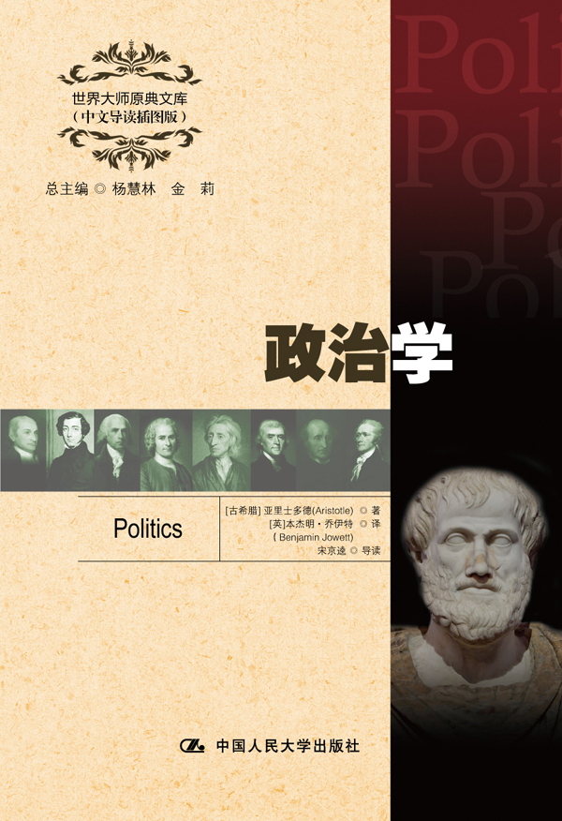插入封面
书号：978-7-300-17215-6
著者：[古希腊] 亚里士多德 著
[英]本杰明·乔伊特 译
宋京逵 导读
责任编辑：王琼
成品：148*210 页数：305
纸张：70克高白胶
装祯：平装
出版时间：2013年4月
定价：26.00元
出版社：中国人民大学出版社

- 本书卖点
- 亚里士多德有关政治哲学重要思想的体现
- 全面、精彩、详实的中文导读
- 学习英语的珍贵资料

◆ 读者定位
1．全国高等院校英语及相关专业学生
2. 高等院校非英语专业英语学习者及同等英语水平学习者
3. 广大外语教师
4. 哲学、文化、政治及法律等各领域的研究学者及学生

- 作者简介
亚里士多德（前384—前322年），古希腊斯吉塔拉人，古代史上最伟大的哲学家、科学家和教育家之一。马克思称亚里士多德是古希腊哲学家中最博学的人物，恩格斯称他是古代的黑格尔。作为一位最伟大的、百科全书式的科学家，亚里士多德几乎对哲学的每个学科都做出了贡献。他的著作涉及伦理学、形而上学、心理学、经济学、神学、政治学、修辞学、自然科学、教育学、诗歌、风俗以及雅典宪法。和柏拉图、苏格拉底一起被誉为西方哲学的奠基者。
- 内容简介
《政治学》是公元前325年亚里士多德根据他和他的学生对希腊158个城邦政治法律制度的调查结果写成的。概括而言，本书主要内容和理论贡献有以下几点：使政治学成为独立的学科，开创政治学研究之先；重经验研究方法，把神学束缚下的政治学转变为以人为中心的政治学；提出了理想的政体模式——中产阶级占主体的共和制；主张通过公民教育和培养实现城邦生活的完善与和谐。

◆ 简要目录
BOOK ONE
BOOK TWO
BOOK THREE
BOOK FOUR
BOOK FIVE
BOOK SIX
BOOK SEVEN
BOOK EIGHT

◆ 上架建议
外语/哲学/政治/畅销书

书摘
Every state is a community of some kind, and every community is established with a view to some good; for mankind always act in order to obtain that which they think good. But, if all communities aim at some good, the state or political community, which is the highest of all, and which embraces all the rest, aims at good in a greater degree than any other, and at the highest good.
Some people think that the qualifications of a statesman, king, house-holder, and master are the same, and that they differ, not in kind, but only in the number of their subjects. For example, the ruler over a few is called a master; over more, the manager of a household; over a still larger number, a statesman or king, as if there were no difference be-tween a great household and a small state. The distinction which is made between the king and the statesman is as follows: When the government is personal, the ruler is a king; when, according to the rules of the political science, the citizens rule and are ruled in turn, then he is called a statesman.
But all this is a mistake; for governments differ in kind, as will be evident to any one who considers the matter according to the method which has hitherto guided us. As in other departments of science, so in politics, the compound should always be resolved into the simple elements or least parts of the whole. We must therefore look at the elements of which the state is composed, in order that we may see in what the different kinds of rule differ from one another, and whether any scientific result can be attained about each one of them.

